**Skilled Qualifications or Tertiary education Qualification deliver better value to the economy?**

**Abstract-** *Tertiary education provides a small, but important, contribution to driving economic growth. The quality of the skills graduates bring to their work is more important than simply the number of people in the workforce holding qualifications. These skills are most productive where businesses have the capital, management skills, scale and links to the economy to support innovation and productivity gains.*

**Introduction**

This report asks how skilled qualifications or tertiary education qualifications can deliver better value to the economy. This report begins with a review of the evidence for the influence of education on economic performance. It then looks at where Singapore is placed with regard to tertiary education qualifications attainment and economic performance. This lead to a question where do employers value educational qualifications or skills qualifications and how does it deliver better value to the economy.

**Overview of Singapore’s Education System**

Singapore has 365 schools altogether, including primary schools, secondary schools, junior colleges, and mixed-level schools. There are different paths which lead to a university degree or a job. However, the first steps into the education system in Singapore usually start with pre-school. Singaporean children attend pre-school up to the age of six, getting prepared for primary school.

After six years of primary school, children move on to secondary school. The education system in Singapore allows students to choose a path at this point. They can decide whether they wish to attend a normal secondary school, a specialized school, an integrated program, or some other institution which offers a similar education. Post-secondary education takes between one and three years and offers a choice of schools, including junior colleges, polytechnics, and institutes of technical education.

Figure 1: Overview of Singapore’s Education System

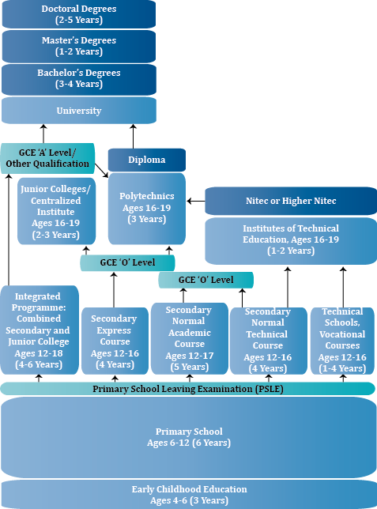

Source: <http://www.ncee.org/programs-affiliates/center-on-international-education-benchmarking/top-performing-countries/singapore-overview/>

**Singapore’s Tertiary education and skilled attainment**

The data cover the Singapore resident population aged 25 years and over who are not attending educational institutions as full-time students. Singapore residents who are upgrading their qualifications through part-time courses while working are included in the data. The Singapore resident population refers to Singapore citizens and permanent residents. Highest qualification attained refers to the highest grade or standard of formal education a person has passed or the highest level of education where a certificate, diploma, or degree is awarded.

At the same time, the educational profile of the Singapore residents’ highest qualification attained has improved over 2009 to 2011. There was a marked increase in the proportion of the population with tertiary qualifications between 2009 and 2011.

University graduates constituted 25 percent of the resident non-student population aged 25 years and over in 2011, up from 23 percent in 2009. (Figure 2).

Persons with diploma and professional qualification also accounted for quite a share of the resident non-student population at 14 percent in 2011, up from 12.4 percent in 2009.

Overall, the tertiary educated accounted for 39 percent of the resident non-student population aged 25 years and over in 2011, up from 37 percent in 2009. This suggests improvements in tertiary education achievement over time.

Figure 2: HIGHEST QUALIFICATION ATTAINED OF RESIDENT NON-STUDENT POPULATION AGED 25 YEARS & OVER, 2009- 2011

**Balance Sheet**

A balance sheet (also known as a statement of financial position) is a formal document that follows a standard accounting format showing the same categories of assets and liabilities regardless of the size or nature of the business.

**Why create a Balance Sheet?**

A balance sheet provides a snapshot of a business’ health at a point in time. It is a summary of what the business owns (assets) and owes (liabilities). Balance sheet are usually prepared at a period where it close to month-end, quarter-end, or year-end. New business owners should not wait until the end of 12-months or at the very last minute to complete a balance sheet. Savvy business owners see a balance sheet as an important decision-making tool.

**Analyzing the Balance Sheet**

Current Ratio:

Does the companies have enough current assets to meet the payment schedule of current liabilities with a margin of safety?

Figure 2: Line graph of current ratio over the years

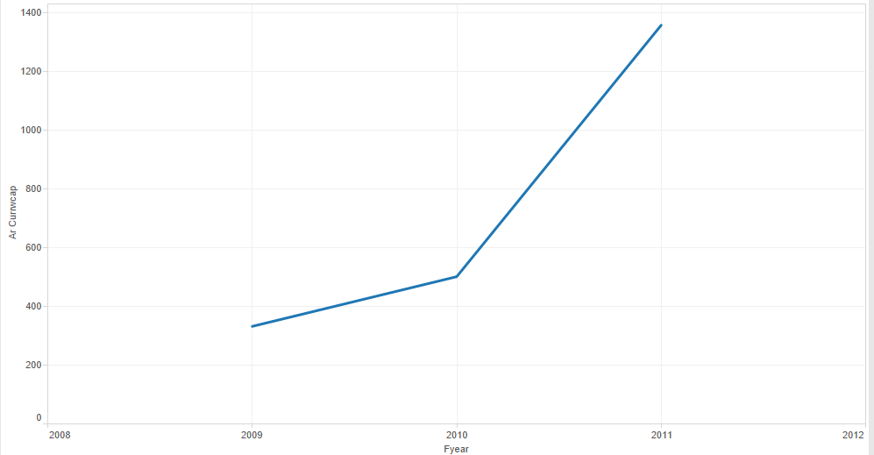

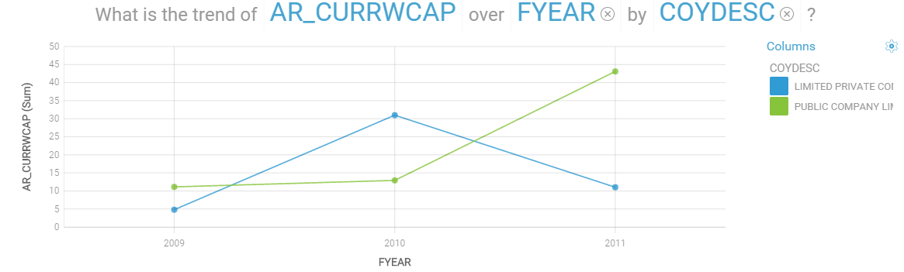

The current ratio (or liquidity ratio) is a measure of financial strength. Here, we have a line graph showing that there is an increase of trend over the years in their current ratio. Increase in current ratio over a period of time may suggest improved liquidity of the company or a more conservative approach to working capital management.

Equity Ratio:

The equity ratio is an investment leverage or solvency ratio that measures the amount of assets that are financed by owners' investments by comparing the total equity in the company to the total assets.

The equity ratio highlights two important financial concepts of a solvent and sustainable business. Companies with higher equity ratios show new investors and creditors that investors believe in the company and are willing to finance it with their investments.

Figure 3: Scatterplot on equity ratio of TTEQUITY vs TTLIAB

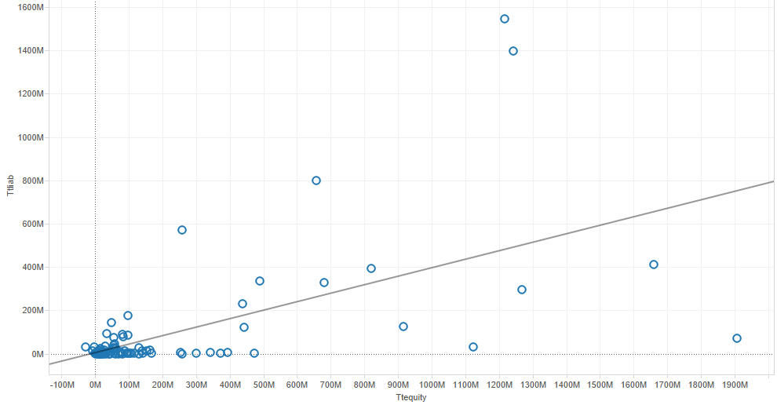

Here, we have a scatterplot showing that the correlation between total liabilities and total equity (r=.60) is strong. As TTEQUITY increases, there is a strong tendency for TTLIAB to increase also. In general, higher equity ratios are typically favorable for companies. A higher ratio also shows potential creditors that the company is more sustainable and less risky to lend future loans.

**Which matters the most—qualifications or skills?**

Skilled

The graphs below shows the number of workers that had gone through Professionals conversion programme from 2009-2011 under the Singapore Workforce Skills Qualifications System. Professional Conversion Programmes (PCP), help jobseekers to re-skill themselves and to obtain the necessary knowledge and competencies to take on new jobs. Some programmes also have a work attachment which helps the individuals to acquire some real experience in the field. This enhances the jobseekers' employability as they have the necessary competencies to take on the new jobs.

Source: <http://www.wda.gov.sg/content/wdawebsite/programmes_and_initiatives/L701E-ProfConversionProgramme.html>

Figure 4: Line graph on Skill workers over the years

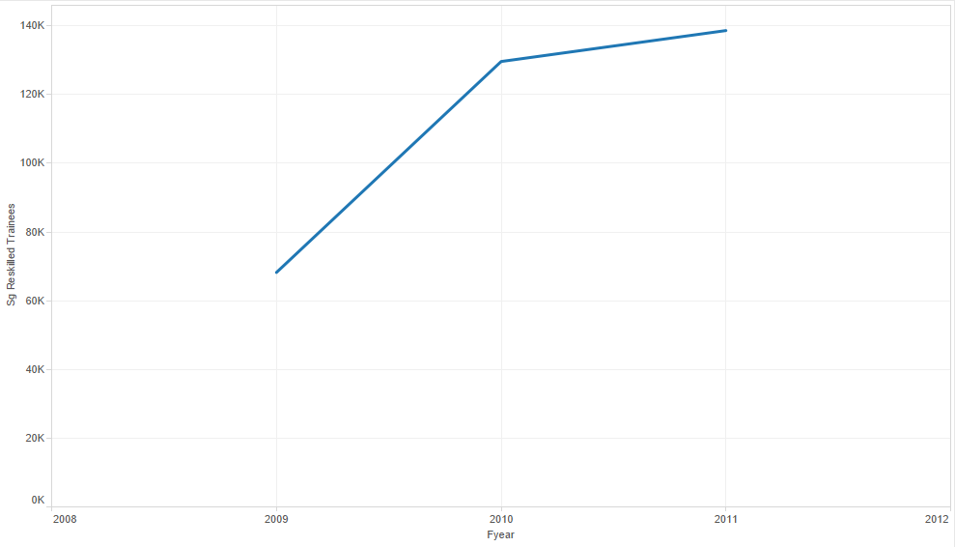

As you can see, the number of people going through PCP is increasing throughout the years which suggests that there is a demand of skilled people in the industry.

Qualification

The graph below shows the number of people surveyed who are Degree holders and Diploma or Professionals holders.

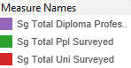Figure 5: Side-by-Side bar chart on Tertiary Education in 2009-2011

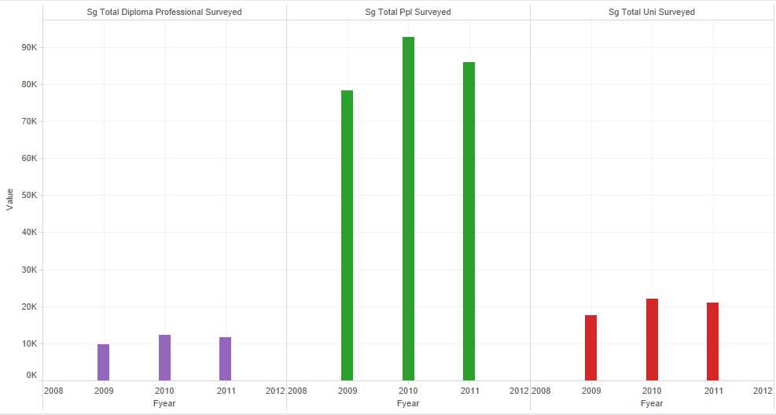

Comparing the diploma and degree holders, there are more Degree holders than Diploma or Professionals holders.

So is higher qualification in demand?

There was a marked increase between 2009 and 2010 in the proportion of population with tertiary qualifications. This shows that more public companies are hiring more employees with tertiary qualifications but in later year, there is a decrease of demand in hiring qualified workers. As for private companies, it remains constant throughout the years. (Figure 6)

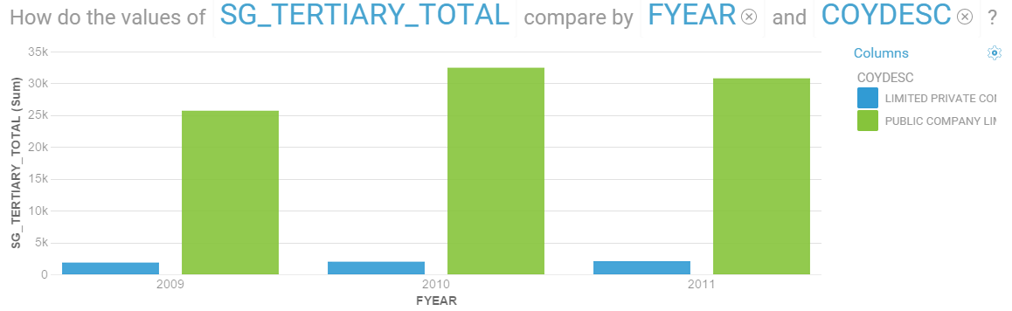Figure 6: Bar chart on Tertiary Qualification residents in 2009-2011

**Do companies hire more skilled workers or tertiary qualification workers?**

Figure 7: Skill workers vs Tertiary qualification workers



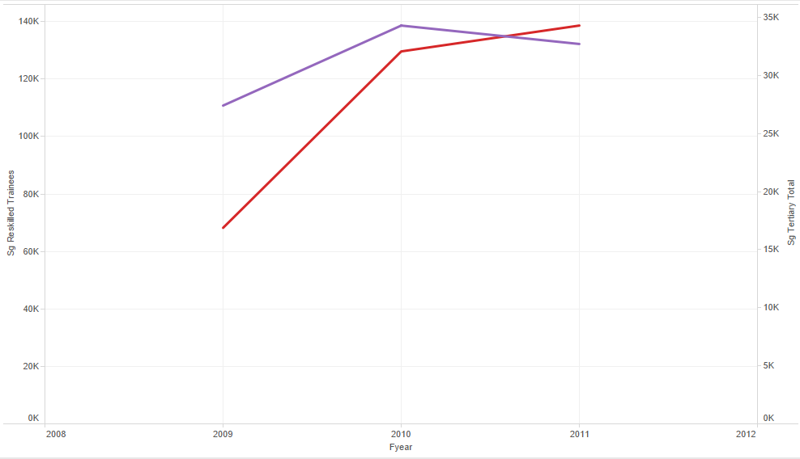

The graph shows that skilled workers are higher in demand compared to tertiary qualification workers between 2010 and 2011. Based on Forbes article on “**The Jobs of the Future Don’t Require A College Degree**”, it says that “Very few of those occupations require college in the sense that 90+% of people who pursue that occupation will benefit from having learned about it in college.” which tells us that workers may need to build the estimation of their work and acquire higher wages, but companies wanting to maximize profits aim to lower their labor costs. So they will go where they can discover workers with the skills they require.

Source: <http://www.forbes.com/sites/pascalemmanuelgobry/2013/05/07/the-jobs-of-the-future-dont-require-a-college-degree/>

**What economic value does Singapore get from its qualifications and skills?**

**What is GDP?**

GDP represents the total dollar value of all goods and services produced over a specific time period. In short, it's everything produced by people and businesses, including salaries of workers.

**What is Total Assets?**

Total Assets are the sum of all current and non-current assets that a company owns. Current assets is in the form of cash and non-current assets is examples lands, machineries. In short, everything the company owned and have.

Source: <http://www.cnbc.com/id/44505017>

Well-being of companies contributes to the economy and thus the GDP. With the merged data, the statement is proven by the graph shown in Figure 8:

Figure 8: GDP per Capita vs Total Assets



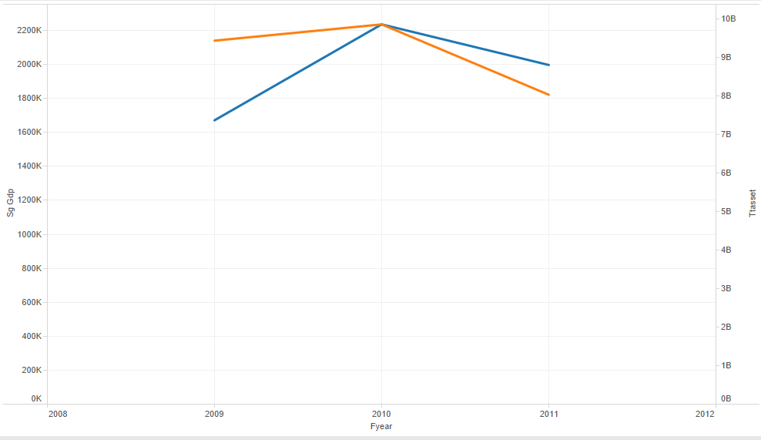

From the graph, we can see that when total assets increases or decreases, GDP follows. Thus, proving that these two effects are somewhat bounded together.

Employment rate contributes to GDP too. When there are more people working, usually the productivity will increase but that depends on how company’s employment based on, skills or qualifications.(Figure 9)

From this [source](http://www.tradingeconomics.com/singapore/employed-persons): a graph was plotted which shows that employment rate affects GDP.

Figure 9: Employment rate vs GDP per Capita

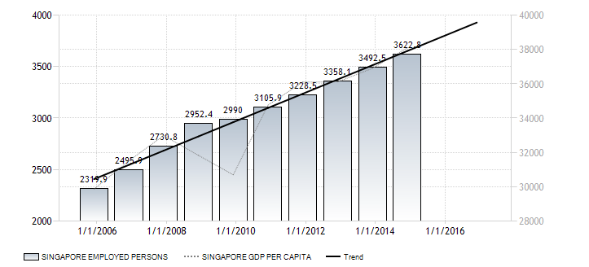

**How associated are Tertiary qualifications and Skill qualifications to GDP?**

The correlation between SG_GDP and SG_TERTIARY_TOTAL (r=.84) is strong showing that they are positively correlated. The quantity r, called the linear correlation coefficient, measures the strength and the direction of a linear relationship between two variables. As SG_GDP increases, there is a strong tendency for SG_TERTIARY_TOTAL to increase also. (Figure 10) Using Pearson’s correlation, the analysis assumes that SG_GDP and SG_TERTIARY_TOTAL have continuous measurement levels. (Figure 11)

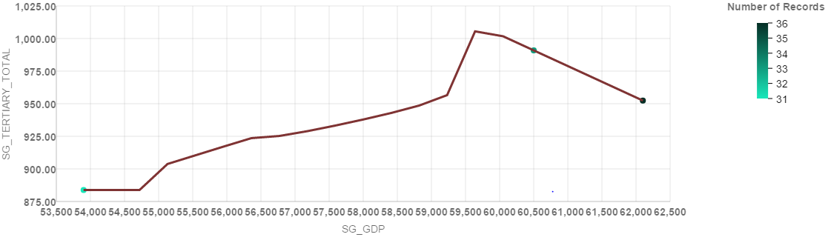Figure 10: Scatterplot of GDP vs Tertiary Qualifications

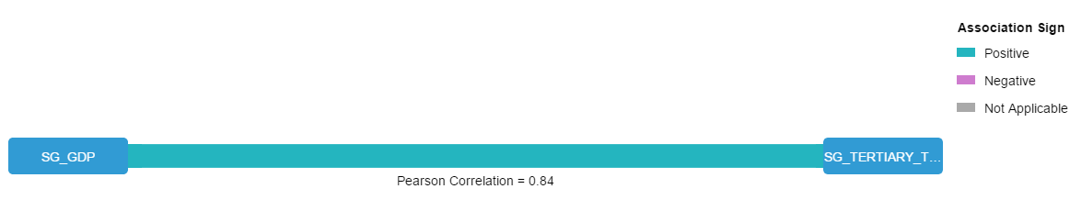Figure 11: Pearson Correlation of SG_GDP and SG_TERTIARY_TOTAL

Skill workers and GDP are positively correlated. Figure 12 is a scatterplot showing the correlation between SG_RESKILLED_TRAINEES and SG_GDP (r=.88) is strong. As SG_RESKILLED_TRAINEES increases, there is a stronger tendency for SG_GDP to increase also. This suggests that skilled workers impacted the economy better than tertiary qualifications.

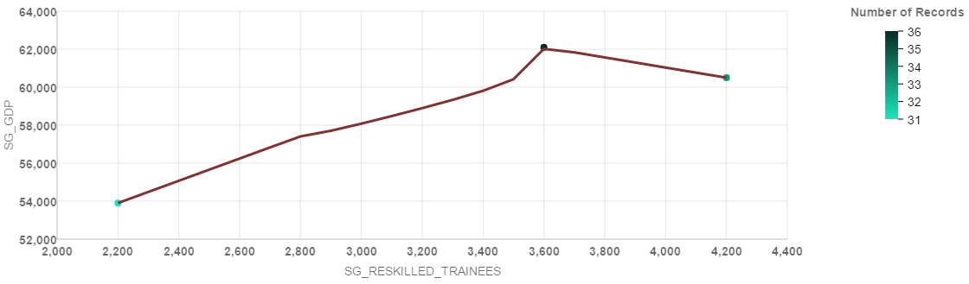Figure 12: Scatterplot of Skill workers vs GDP

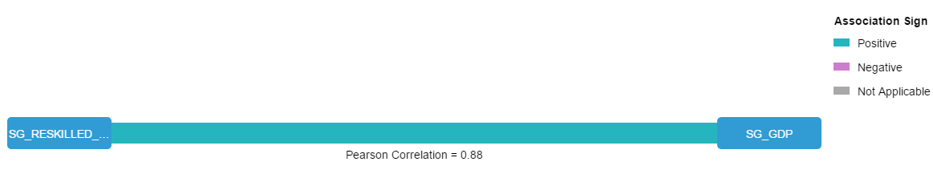Figure 13: Pearson correlation of Skill workers and SG_GDP

**Summary and Conclusion**

In this report, we presented results from dataset that is a subset of a standard report provided by Elixir Technology. We analyzed the balance sheet to look at a snapshot of a business’ health at a point in time, in this case the companies over the year of 2009 to 2011. We explored the data by merging with Singapore’s GDP, records of skill workers and tertiary qualification workers together and visualize the trends in sales figures. We then look at the relationship of these individual employment types (skilled and tertiary qualified) and economic relations to discover correlations. We found statistically significance evidence that skill qualifications deliver better to the economy. Within the scope of this study, we conclude that employing the ideal employees companies’ need which in this case skilled workers are in demand will result in an increase in productivity. Productivity matters because it can drive growth in the quantity and value of national production. This can lead to improved incomes and economic wellbeing.

Datasets:

*Strategic Corporate Information Dataset (from IDA)*

This sample dataset is a subset of a standard report provided by Elixir BizInsights on Strategic Information Report of all Public Listed companies registered with ACRA for the 3 year period, 2009 to 2011. It contains companies' financial information (revenue, profit, etc.) filed for year 2009 to 2011 with accounting ratios. [1]

[http://elixirtech-ckan.cloudapp.net/storage/f/20150626T10%3A29%3A26.789Z/strategic-information-sample.xls](http://elixirtech-ckan.cloudapp.net/storage/f/2015-06-26T10%3A29%3A26.789Z/strategic-information-sample.xls)

Additional Info

|  |  |
| --- | --- |
| **Field** | **Value** |
| **Author** | Elixir Technology |
| **Maintainer** | Elixir Technology |
| **1.0 Version** | 1.0 |
| **1.1 Free/Paid** | Paid |
| **1.2 SSIC Classification 1** | Information and Communications |
| **1.3 SSIC Classification 1.1** | Information Service Activities |
| **1.4 SSIC Classification 2** | Information and Communications |
| **1.5 SSIC Classification 2.1** | Computer Programming, Consultancy and Related Activities |
| **1.6 Quality Indicator 1: Total No. of Records** | 1753 |
| **1.7 Quality Indicator 2: No. of completely filled records/Total no. of records** | 1 |
| **1.8 Quality Indicator 3: No. of empty records/Total no. of records** | 0.0 |
| **1.9 Quality Indicator 4: No. of fields per record** | 28 |
| **2.0 Quality Indicator 5: Dataset last update** | 11/12/2014 12:58:00 PM |
| **2.1 Quality Indicators last generated** | 11/12/2014 12:58:00 PM |
| **Data Field 01: COYNAME** | Company Name |
| **Data Field 02: REGNO** | UEN |
| **Data Field 03: ACCTYPEDESEC** | Type of Account Filed |
| **Data Field 04: COYDESC** | Type of Company |
| **Data Field 05: FYEAR** | Year of Financial Filing. Data for the past 3 years, 2009 to 2011 |
| **Data Field 06: REVENUE_AMT** | Revenue f.k.a [Sales Turnover And Other Operating Revenues] |
| **Data Field 07: PBFTAX** | Profit before Tax from Continuing Operations f.k.a [Profit before Tax] |
| **Data Field 08: LBFTAX** | Loss before Tax from Continuing Operations f.k.a [Loss before Tax] |
| **Data Field 09: PAFTAX** | Profit after Tax from Continuing Operations f.k.a [Profit After Tax] |
| **Data Field 10: LAFTAX** | Loss after Tax from Continuing Operations f.k.a [Loss After Tax] |
| **Data Field 11: TTASSET** | Total Assets |
| **Data Field 12: TTCRASSET** | Total Current Assets |
| **Data Field 13: TTNCRASSET** | Total Non-Current Assets |
| **Data Field 14: TTLIAB** | Total Liabilities |
| **Data Field 15: TTCRLIAB** | Total Current Liabilities |
| **Data Field 16: TTNCRLIAB** | Total Non-Current Liabilities |
| **Data Field 17: TTEQUITY** | Total Equity f.k.a. [Shareholder's Funds] |
| **Data Field 18: PUCAP** | Paid-Up Capital |
| **Data Field 19: SHARECAP** | Share Capital |
| **Data Field 20: OTHERRESERVESTT** | Other Reserves, Total f.k.a. [Reserves] |
| **Data Field 21: RETAINEARN** | Retained Earnings/(Accumulated Loss) |
| **Data Field 22: AR_NETPROFITSALES** | Rate of Net Profit on Sales (%). Derived value from the formula: 100 * Net Profit After Tax / Turnover (Sales) |
| **Data Field 23: AR_RETINVESTMENT** | Return of Investment (%). Derived value from the formula: 100 * Net Profit After Tax / Total Assets |
| **Data Field 24: AR_RETSHAREFUNDS** | Return of Shareholder's Funds (%). Derived value from the formula: 100 * Net Profit After Tax / Shareholder's Funds |
| **Data Field 25: AR_TASSETSTO** | Total Assets Turnover (%). Derived value from the formula: Turnover (Sales) / Total Assets |
| **Data Field 26: AR_CURRWCAP** | Current/Working Capital Ratio (%). Derived value from the formula: Current Assets / Current Liabilities |
| **Data Field 27: PROPRATIO** | Proprietary Ratio(%). Derived value from the formula: 100 * Shareholder's Funds / Total Assets |
| **Data Field 28: AR_TOTALDEBT** | Total Debt to Equity Ratio (%). Derived value from the formula: 100 * Total Liabilities / (Total Liabilities + Shareholder's Funds) |

*Highest Qualification Attained Dataset*

**Singapore Residents Aged 25 Years & Over By Highest Qualification Attained, Sex, And Age Group, Annual**:

Data pertain to residents who are not attending educational institutions as full-time students. The data include those who are upgrading their qualifications through part-time courses while working.

Highest Qualification attained refers to the highest grade or standard of formal education a person has passed or the highest level of education where a certificate, diploma, or degree is awarded. The educational qualification may be attained through full-time or part-time study in a structured educational programme. [2]

<http://www.tablebuilder.singstat.gov.sg/publicfacing/mainMenu.action>

Additional Info

|  |  |
| --- | --- |
| **Field** | Value |
| SG_TOTAL_PPL_SURVEYED | Singapore Residents Aged 25 Years & Over |
| SG_TOTAL_UNI_SURVEYED | Total University(Males & Females) |
| SG_TOTAL_DIPLOMA_PROFESSIONAL_SURVEYED | Total - Diploma & Professional Qualification (Males & Females) |

*GDP Per Capita- US$ Dataset:*

**Definition:**

GDP per capita is gross domestic product divided by midyear population. GDP is the sum of gross value added by all resident producers in the economy plus any product taxes and minus any subsidies not included in the value of the products. It is calculated without making deductions for depreciation of fabricated assets or for depletion and degradation of natural resources. Data are in current U.S. dollars. GDP per capita provides a general measure of economic performance and wellbeing. [3]

<http://www.indexmundi.com/g/g.aspx?v=67&c=bg&l=en>

Additional Info

|  |  |
| --- | --- |
| **Field** | Value |
| SG_GDP | gross domestic product of Singapore |

*Workers Trained under Singapore Workforce Skills Qualifications System, 2004-2013 Dataset*

**Professional Conversion Programmes:**

Professional Conversion Programmes, help jobseekers to re-skill themselves and to obtain the necessary knowledge and competencies to take on new jobs. Some programmes also have a work attachment which helps the individuals to acquire some real experience in the field. This enhances the jobseekers' employability as they have the necessary competencies to take on the new jobs. Hence jobseekers, including mid-career individuals, can take on a new job with greater confidence. [4]

<http://stats.mom.gov.sg/iMAS_Tables/YearBook/YearBook_2014/mrsd_2014YearBook_HEStableH_12.xlsx>

Additional Info

|  |  |
| --- | --- |
| **Field** | Value |
| SG_RESKILLED_TRAINEES | People who went through Professional Conversion Programmes |

Merging using R

We use “merge()” function in RStudio which will have additional columns in the original dataframe.

The following is the codes that we’ve used:

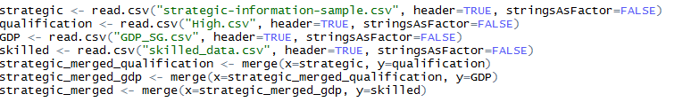

Then we write it to csv file:



We use thousand separator by calling the “gsub()” function and to separate the commas in order to convert it to numeric by using “as.numeric()” function:

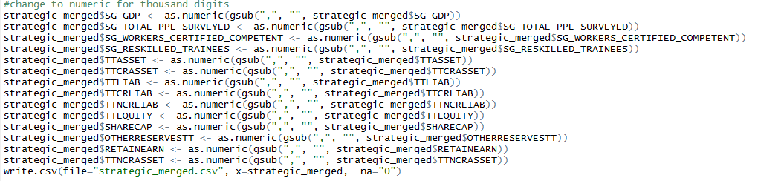

Merged Data: <https://www.dropbox.com/s/0xmhfbdgs17k7x1/strategic_merged.csv?dl=0>

Additional References

[1] Strategic Corporate Information Dataset for Data Challenge, Elixir Technology

[2] Singapore Residents Aged 25 Years & Over By Highest Qualification Attained, Sex, And Age Group, Annual: SINGAPORE DEPARTMENT OF STATISTICS

[3] GDP Per Capita- US$

[4] Workers Trained under Singapore Workforce Skills Qualifications System,2004-2013